**Learners Academy**

Learner’s Academy is a school that has an online management system. The system keeps track of its classes, subjects, students, and teachers. It has a back-office application with a single administrator login.

**The administrator can:**

● Set up a master list of all the subjects for all the classes  
● Set up a master list of all the teachers  
● Set up a master list of all the classes  
● Assign classes for subjects from the master list  
● Assign teachers to a class for a subject (A teacher can be assigned to different classes for different subjects)  
● Get a master list of students (Each student must be assigned to a single class)

**View project locally**

To try out the project in your local machine:

* clone this repository using git clone
* Open the folder from Eclipse/IntelliJ
* Open index.html and Run

## **Sprints planning and Task completion**

The project is planned to be completed in 1 sprint.

## **Core concepts used in project**

Object oriented programing ,Classes, Methods, Array list, MySql, Hibernate , Servlet, Data Structures, HTML

Technologies used

Java

Git Hub

## **Steps:**

## Creating a new project in Eclipse

* Open Eclipse
* Go to File -> New -> Project -> Dynamic Web Project ->Finish
* Type in project name “phas2” and click on “Finish.”
* Select your project and go to src->main->Java
* Create required servlet pages
* Go to Web app-
* Create required html pages of project
* Also configure an xml file hibernate.cfg.xml in src/main/java folder
* Add required hibernate jar files, mysql connector jars and servlet api jar

**Run Project :**

To run project open index.html page in webapp folder

Start server and click Run as

The Project folder structure is as follows :

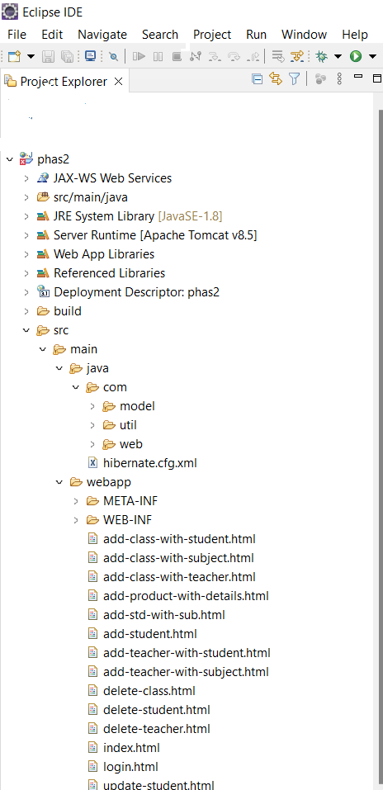

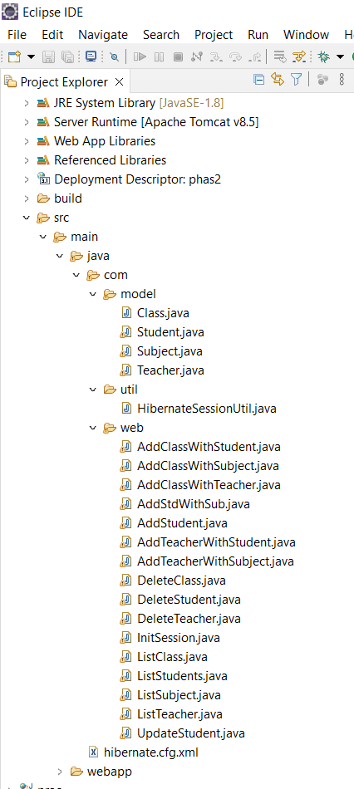

**Project output :**

Open index.html in web app folder and click run as

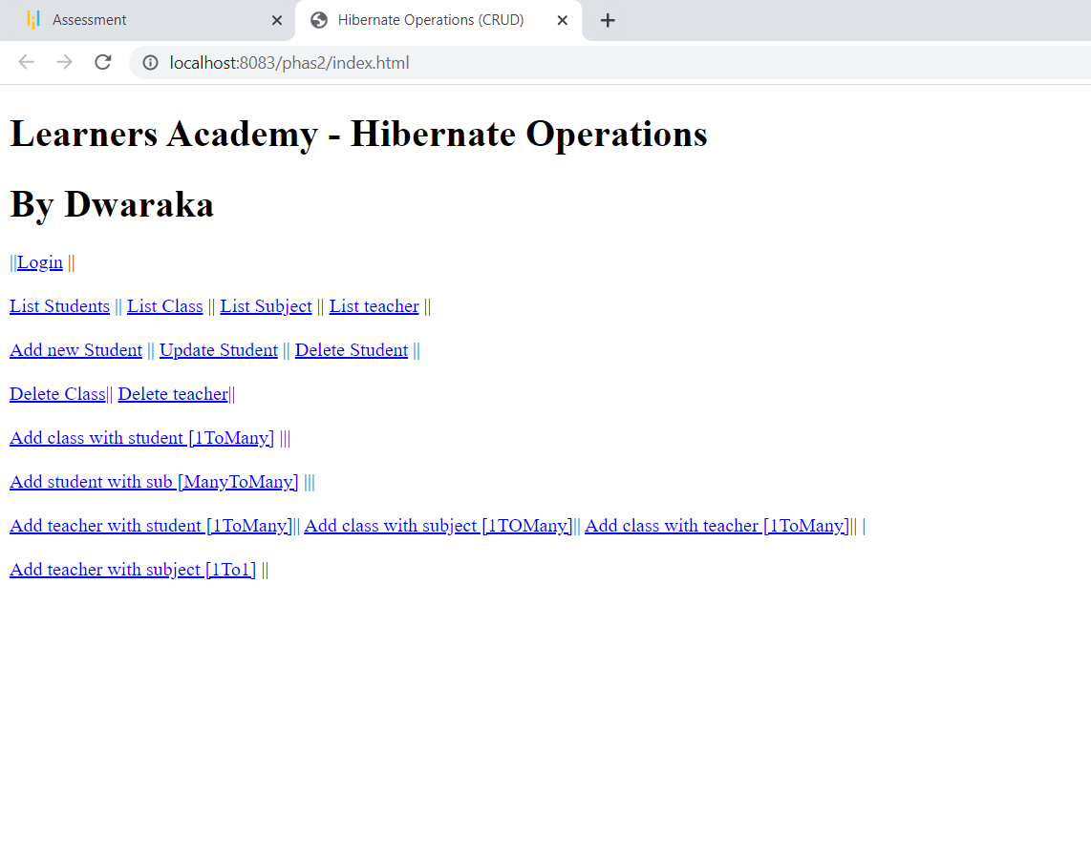

Click login first and provide credentials as

Username : admin

Password : admin

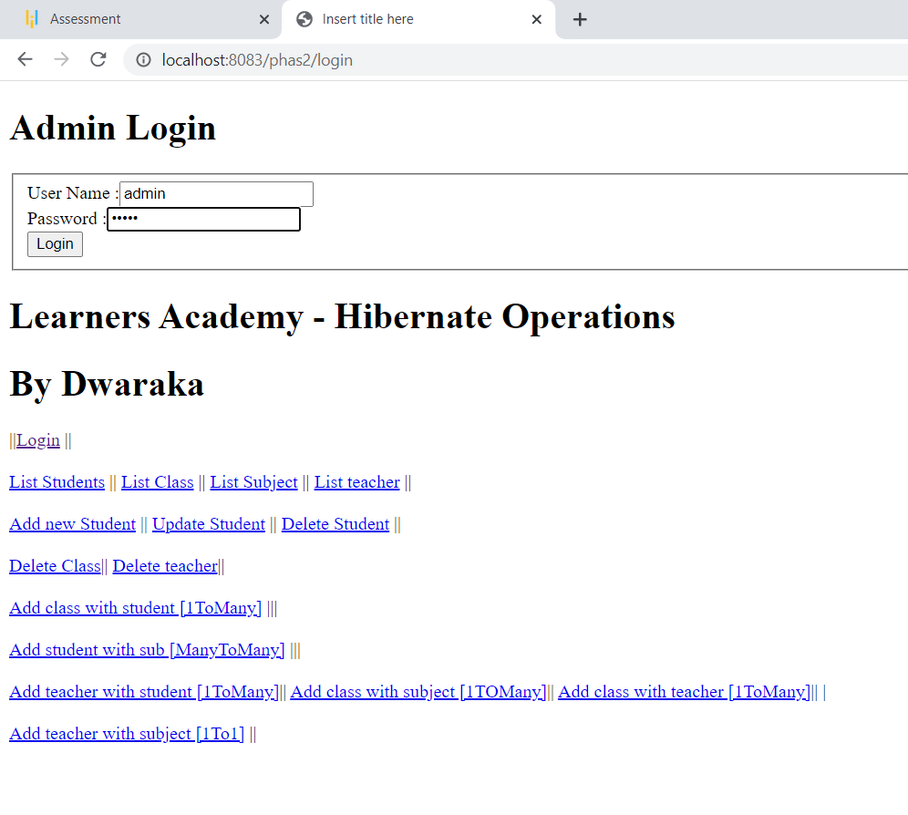

Perform operations from the list

